Word Document Template for CIM Programs
(including Graduate College Request & Justification Form for Program Classification)

Proposal Type
- This proposal is a: concentration / degree / joint program / major / minor (Choices on New Only)
  - The Bachelor of Science (BS) is a degree. The Accountancy, BS is an Accountancy major within a Bachelor of Science degree. The Anthropology: Archaeology, BALAS is a concentration in Archaeology within the major of Anthropology within the Bachelor of Liberal Arts and Sciences degree.

For a Revision Proposal
- This proposal is for a Phase Down/Elimination or Revision (pick one – Revision is default)

Administration Details

- Official Program Name (Easily identifiable, Short Title no more than 100 characters):

- Sponsor College:

- Sponsor Department:

- Sponsor Name (Department Head or Center Director. 2 contacts are possible):

- Sponsor Email:

- College Contact (College contact best able to answer possible EPC questions or knows who can answer questions.):

- College Contact Email:

- College Budget:

- College Budget Officer Email:

- List the role for rollbacks (which role (i.e., 1415 Committee) will edit the proposal on questions from EPC) and/or any additional stakeholders.)

- Does this program have inter-departmental administration?
Is this program administered/managed by more than one dept/college? It is NOT referring to curricular content being in more than one dept. If select Yes, choose the additional college(s) and department (s) that will manage the new program. Can add 1+ colleges/departments.)
Yes / No (No is default.)
  - If Yes, please describe the oversight/governance for this program. Inclusion of/roles of elected faculty committees? Advisory committees?

Proposal Title

- Effective Catalog Term

Enter the starting term for the program, which means when the program will be listed in the Academic Catalog (official marketing). It doesn’t necessarily mean Admissions date as program approval date can affect Admissions date. Please note that it takes about a year for a curriculum revision, concentration, or a joint degree to be approved. It can take two years for a brand new major to be approved and reflected in the Academic Catalog.):

- Provide a brief, concise description (not justification) of your proposal
  - Short description of the proposal/revision. Be sure to include information on WHAT is changing in a revision – not just that it is a change to the program; that is understood by the fact that you are initiating the form.
    - Simple example for a new program: Establish a major in Wizardry within the Master of Science Degree.
    - Simple example for a revision: Update the major electives course list for the Bachelor of Science in Physics.
- List here any related proposals/revisions and their keys. Example: This BS proposal (key 567) is related to the Concentration A proposal (key 145) and the Concentration B proposal (key 203).

Program Justification
- (New Proposals) Provide a brief justification of the program, including highlights of the program objectives, and the careers, occupations, or further educational opportunities for which the program will prepare graduates, when appropriate.
The sponsor must articulate why it is important to implement this new program. If needed, a sponsor can attach any charts, graphs, or additional supporting documentation).

For a Revision Proposal
- Why are these changes necessary?
Consider this a very brief justification section. What prompted the sponsor to make the changes?

For Minors Only (New Only)
- Please include how the proposed minor requires some depth in the subject, but not as extensive as the major.

Instructional Resources
- Will there be any reduction in other course offerings, programs, or concentrations by your department as a result of this new program/proposed change? (These questions ask for reflection on course offerings depending on the new program or revision.)
Yes / No (No is default.)
  - If yes, please describe.

- Does this new program/proposed change result in the replacement of another program?
Yes / No (No is default.)
  - If yes, Choose program being replaced.

- Does the program include other courses/subjects impacted by the creation/revision of this program?
Yes / No (No is default.)
  - If yes, list the required courses, explain how the inclusion or removal of the courses/subjects listed above impacts the offering departments
  - And attach letters of support from other departments.

Program Regulation and Assessment

- Briefly describe the plan to assess and improve student learning, including the program’s learning objectives; when, how, and where these learning objectives will be assessed; what metrics will be used to signify student’s achievement of the stated learning objectives; and the process to ensure assessment results are used to improve student learning. (Describe how the program is aligned with or meets licensure, certification, and/or entitlement requirements, if applicable).

- Is the career/profession for graduates of this program regulated by the State of Illinois?
Yes / No (Default is No)
  - If yes, please describe.

For Programs Housed Outside of a Department Proposal (PHOD)
- Describe how interdisciplinary governing councils or committees are composed, selected and maintained.

Program of Study
Baccalaureate degree at least 120 semester credit hours or 180 quarter credit hours and at least 40 semester credit hours (60 quarter credit hours) in upper division courses”
(source: https://www.ibhe.org/assets/files/PrivateAdminRules2017.pdf).
For proposals for new bachelor’s degrees, if this minimum is not explicitly met by specifically-required 300- and/or 400-level courses, please provide information on how the upper-division hours requirement will be satisfied.
(for Minor Proposals Only)
An undergraduate minor should consist of at least 16 - and no more than 21 hours - of course work, with at least 6 hours of 300- or 400- level courses. Except clearly remedial offerings, prerequisite courses within the sponsoring unit count towards the total; prerequisite courses outside the sponsoring unit do not count toward this total. The unit sponsoring the minor and that unit's college may set educationally necessary prerequisites for eligibility for the minor within these constraints.
Yes/No (Default is Yes.)
  - If No, Please provide specifics as to how the minor does not meet these criteria and the rationale.

All Proposals
- All proposals must attach the new or revised version of the Academic Catalog program of study entry. Contact your college office if you have questions. For new programs, attach Program of Study OR Fill in the Statement for Programs of Study Catalog below

- Catalog Page Text – Overview Tab. Not Required. Text for Overview tab on the Catalog Page. This is not official content, it is used to help build the new catalog page for the program. Can be edited in the catalog by the college or department.

On Revision Proposals
- Required. Attach a side-by-side comparison with the existing program AND, if the revision references or adds “chose-from” lists of courses students can select from to fulfill requirements, a listing of these courses, including the course rubric, number, title, and number of credit hours.

- Statement for Programs of Study Catalog – this area will be filled out by College level Personnel – Attach table

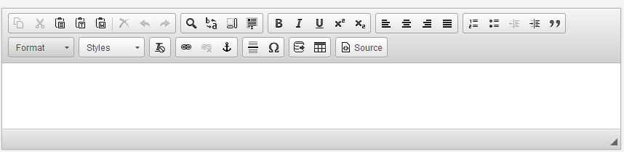

Program Relationships

- For Major
  - List Corresponding Degree (BS, BA, CERT, MS, MA, PhD, etc.)
- For Concentration
  - List corresponding Program(s) (Graduate Concentrations can have multiple majors)
- For Joint Programs
  - List corresponding Program(s) to be joined

Program Features
- Academic Level (Two choices are possible for Joint Programs):
  - Undergraduate
  - Graduate
  - Professional

For Major Proposals Only
- Does this major have transcripted concentrations?
Yes/No
If yes:
  - Will you admit to the concentration directly? Yes/No
  - Is a concentration required for graduation? Yes/No

- What is the typical time to completion of this program? (List the typical number of months/years for a student to finish this program. List the longest permissible time, not the shortest. Campus Grad Certificates (CERT) require at least 10 weeks).

- What are the minimum Total Credit Hours required for this program?

- If Graduate Program, what is the required GPA?

- CIP Code (For more information on CIP codes, see the Classification of Instructional Programs’ website, https://nces.ed.gov/ipeds/cipcode/Default.aspx?y=56. For example, the CIP Code for the Master of Veterinary Science in Livestock Systems Health is 01.0903, Animal Health)

- Is this a Teacher Certification Program? Yes/No

- Will specialized accreditation be sought for this program? Yes/No

For Minor Proposals
- Is this minor?
  - A Comprehensive study in a single discipline
  - An interdisciplinary study focusing on a single theme
  - Exception
    - If an exception: Please explain and justify

- Other than certification via the students’ degree audits, is there any additional planned mechanism to award/honor successful completion of the minor?
Yes/No (no is default)
  - If Yes, Please Describe

For Concentration Proposals
- List any Additional concentration notes (e.g., estimated enrollment, advising plans, etc.)

Delivery Method
- This program is available (choose one):
  - On Campus – Students are required to be on campus, they may take some online courses.
  - On Campus and Online – 2 program types. Students can receive the entire program either on campus or online. Students can choose to take courses in either modality.
  - Online Only – The entire program is delivered online, students are not required to come to campus.
  - Blended – A single program in which students are required to take part of the curriculum on campus and another part in a different location or online.
- Describe the use of this delivery method (This not required for on campus programs. Give a short description of the program delivery for any of the other methods.)

Institutional Context (Only required if proposing a new Major, Joint Program or Degree)
University of Illinois at Urbana-Champaign
Mission: The University of Illinois at Urbana-Champaign is charged by our state to enhance the lives of the citizens in Illinois, across the nation and around the world through our leadership in learning, discovery, engagement and economic development.
- Describe the historical and university context of the program's development. Include a short summary of any existing program(s) upon which this program will be built. Explain the nature and degree of overlap with existing programs and, if such overlap exists, document consultation with the impacted program’s home department(s).

University of Illinois at Urbana-Champaign
University of Illinois' mission: The University of Illinois will transform lives and serve society by education, creating knowledge and putting knowledge to work on a large scale and with excellence.
- Briefly describe how this program will support the University's mission, focus and/or current priorities. Demonstrate the program's consistency with and centrality to that mission.

Admission Requirements (Only required if proposing a new Major, Joint Program or Degree)
- Desired Admission Term:
- Provide a brief narrative description of the admission requirements for this program. Where relevant, include information about licensure requirements, student background checks, GRE and TOEFL scores, and admission requirements for transfer students.

- Describe how critical academic functions such as admissions and student advising are managed.

Enrollment
- Number of Students in Program Estimates:
Year One Estimate:
5th Year Estimate (or when fully implemented):

- Estimated Annual Number of Degrees Awarded
Year One Estimate:
5th Year Estimate (or when fully implemented):
- What is the matriculation term for this program? (not required for joint programs)
  - Fall
  - Spring/Summer/Other
Please give an explanation of why fall matriculation is not applicable:

Enrollment questions for Minor Proposals
- Will the department limit enrollment to the minor?
Yes/No
- Describe how the department will monitor the admission to/enrollment in the minor

- Are there any prerequisites for the proposed minor?
Yes/No (no is default)
  - If Yes, Please Describe

Enrollment questions for Minors and Concentration Proposals
- Number of Students in Program Estimates
Year One Estimate: 5th Year Estimate (or when fully implemented):

Budget
- Will the program or revision require staffing (faculty, advisors, etc.) beyond what is currently available? Yes/No
  - If yes, please explain/describe:

- Additional Budget information (text box and file attachment available)

Financial Resources
- How does the unit intend to financially support this proposal?
Sponsors must give a brief overview of how the program will be financially supported and whether the unit will financial support outside of the college. If it is a Campus Graduate Certificate proposal then include the proposed tuition rate either as part of the response to the question “How does the unit intend to financially support this proposal?” or use the green “Attach File” to upload a document with this information.

- Will the unit need to seek campus or other external resources?
Yes/No
  - If yes, please provide a summary of the sources and an indication of the approved support.

Only required if proposing a new Major or Concentration
- What tuition rate do you expect to charge for this program?
e.g., Undergraduate Base Tuition or Engineering Differential or Social work online (no specific $$ amount needed)

- Is this program requesting self-supporting status?
If program is self-supporting status or requesting self-supporting status, there is a form that must be uploaded and attached to the proposal. Contact the Graduate College and/or your College Office for the form and assistance with how to respond to the questions on the form.
Yes/No (no is default)

Resource Implications
Facilities
- Will the program require new or additional facilities or significant improvements to already existing facilities? Yes/No (Default is NO additional facilities are required.)
  - IF YES: Sponsors must articulate the program needs for a new or improved facility and the costs associated in years 1 and 5.

Year One Estimate:
5th Year Estimate (or when fully implemented):

Technology
- Will the program need additional technology beyond what is currently available for the unit?
Yes/No (Default is NO additional technology is required.)
  - IF YES: Sponsors must articulate the program needs for additional technology and the costs associated in years 1 and 5.

Year One Estimate:
5th Year Estimate (or when fully implemented):

Non-Technical Resources
- Will the program require additional supplies, services, or equipment (non-technical)?
Yes/No (Default is NO additional supplies, services, or equipment are required.)
  - IF YES: Sponsors must articulate the program needs for additional supplies, services, or equipment and the costs associated in years 1 and 5.)

Year One Estimate:
5th Year Estimate (or when fully implemented):

Resources
For each of these items (Faculty Resources and Library Resources), be sure to include in the response if the proposed new program or change will result in replacement of another program(s). If so, which program(s), what is the anticipated impact on faculty, students, and instructional resources?

- Please attach any letters of support/acknowledgement from faculty, students, and/or other impacted units as appropriate.

Faculty Resources (Not required for Minor)
- Please address the impact on faculty resources including any changes in numbers of faculty, class size, teaching loads, student-faculty ratios, etc. Describe how the unit will support student advising, including job placement and/or admission to advanced studies.

Library Resources
- Describe your proposal’s impact on the University Library’s resources, collections, and services. If necessary, please consult with the appropriate disciplinary specialist within the University Library.
If no additional library resources are needed, note: "Library collections, resources and services are sufficient to support..."

Market Demand (For proposing a new Major or Joint Program)

- What market indicators are driving this proposal? If similar programs exist in the state, describe how this program offers a unique opportunity for students.
- Explain how the program will meet the needs of regional and state employers, including any state agencies, industries, research centers, or other educational institutions that expressly encouraged the program’s development.
- Discuss projected future employment and or additional educational opportunities for graduates of this program. Compare estimated demand with the estimated supply of graduates from this program and existing similar programs in the state. Where appropriate, provide documentation by citing data from such sources as employer surveys, current labor market analyses, and future workforce projections. (Whenever possible, use state and national labor data, such as that from the Illinois Department of Employment Security at http://ides.illinois.gov/ and/or the U.S. Bureau for Labor Statistics at http://www.bls.gov/).

- What resources will be provided to assist students with job placement?

Graduate College Request & Justification Form for Program Classification (if needed)
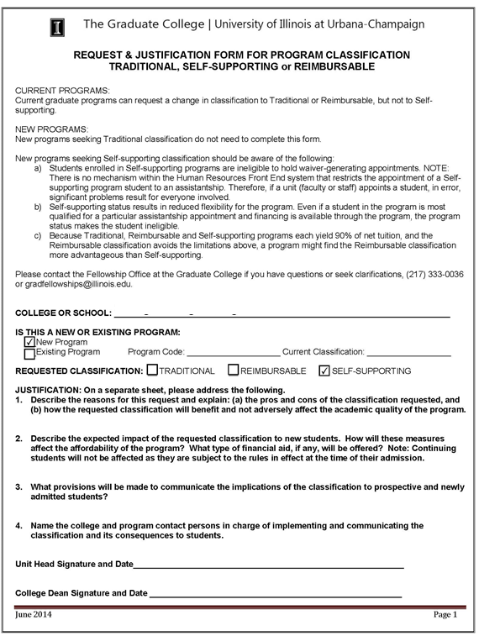

1) Describe the reasons for this request and explain: (a) the pros and cons of the classification requested, and (b) how the requested classification will benefit and not adversely affect the academic quality of the program.

2) Describe the expected impact of the requested classification to new students. How will these measures affect the affordability of the program? What type of financial aid, if any, will be offered? Note: Continuing students will not be affected as they are subject to the rules in effect at the time of their admission.
3) What provisions will be made to communicate the implications of the classification to prospective and newly admitted students?

4) Name the college and program contact persons in charge of implementing and communicating the classification and its consequences to students.

